**How to make an appointment for help with a tutor in the Math Center**

* **Click on the Library link inside the Blackboard**

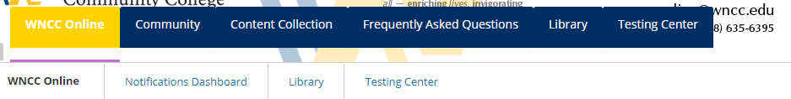

* **Click on the WNCC Library Website**

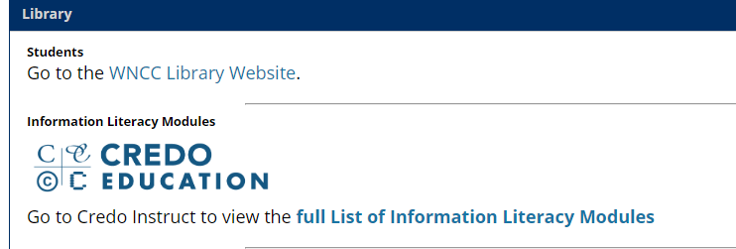

* **Click on reserve a space**

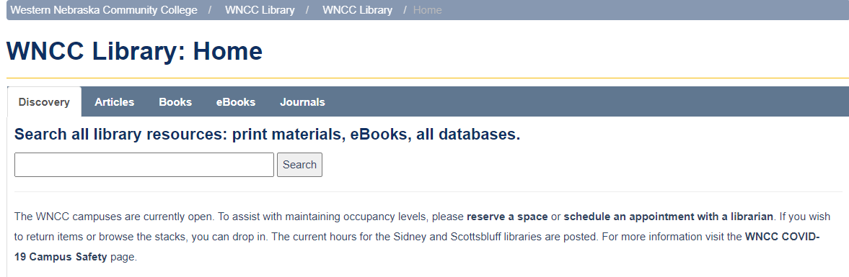

* **Go to Location and pull the arrow down next to WNCC Library**
* **Change location to Math Center**

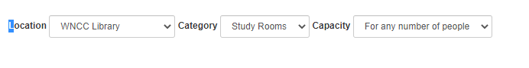



* **Go to a date and time – Select a specific date**
* **Select a specific time by clicking on the box in that time spot**

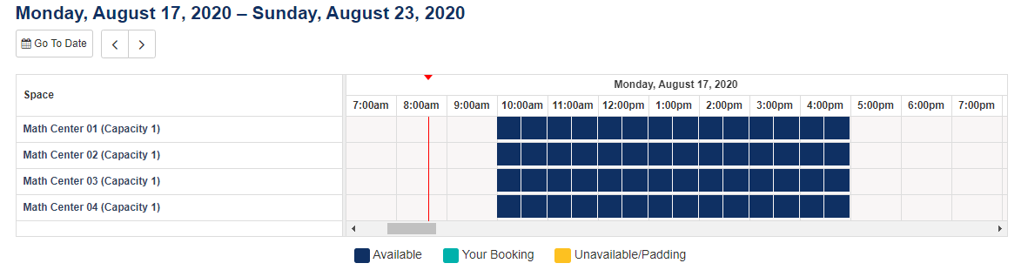

* **Scroll down and select submit times**

